We are pleased to inform you that applications for Mikiel Anton Vassalli Courses are now open.
To apply, please visit: 👉 https://mavc.gov.mt/apply
You will be redirected to the login page shown below.

For New Students:
Please click on the Accounts Sign-Up link. You will be redirected to the e-ID page. Follow the instructions provided to create your account.
If you encounter any issues with the e-id kindly call +356 25904300 for assistance
Registering your child:
If you are registering your child, when applying they select the second option and enter the details of the child.
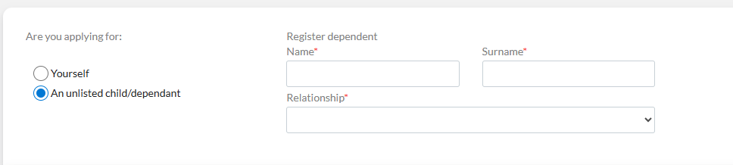

Registering yourself:
Select Yourself ONLY if you want to register yourself for one of our courses.

For Returning Students:
You may proceed to the Login page directly. If you have forgotten your password, click on Recover Password, and a reset link will be sent to your registered email address.
If you encounter any issues or have questions, feel free to contact us at:
📧 mavassalli.college@ilearn.edu.mt
